The Conversion of Organic Wastes into Vermicomposts and Vermicompost ‘Teas’ Which Promote Plant Growth and Suppress Pests and Diseases.

Clive A. Edwards*, Norman Q. Arancon*, Tse Chi Kai**, and David Ellery**

*Soil Ecology Laboratory, The Ohio State University, Columbus, OH, USA

** Sunburst Waste Management Technologies Ltd, Australia

Introduction

Most people are familiar with the principles of thermophilic composting, which is a microbial process that utilizes certain aerobic microorganisms to break down organic materials such as wastes. This process involves an aerobic, microbial heating process, which raises the temperature of the organic materials to 55˚ – 70˚ C for at least 72 hours, followed by a maturation phase of several days. This process depends on keeping the organic materials aerated, either by turning organic piles mechanically, or by injecting air into enclosed systems. The product has a number of uses as field soil amendments, but has a relatively poor structure and comparatively limited amounts of plant-available nutrients. (Edwards and Bohlen, 1996; Edwards and Arancon, 2004).

More recently, there has been considerable world-wide interest and significant technological progress, particularly at The Ohio State University, on the production and optimal uses of vermicomposts. Vermicomposts can be processed from most organic wastes such as animal manures, and particularly, paper and food wastes, through interactions between earthworms and microorganisms, in a mesophilic process (up to 35˚ C), to produce fully-stabilized materials with low carbon to nitrogen ratios. They have high and diverse enzymatic and microbial activities and contents, a fine particulate structure, good moisture-holding capacity and contain nutrients such as nitrogen, potassium, and calcium in forms readily taken up by plants. Vermicomposts can have dramatic effects upon the germination, growth, flowering, fruiting and yields of most crops, particularly fruit and vegetables, which are high value crops.

Because vermicomposts are so rich in plant-available nutrients, they tend to perform best in promoting plant growth and yields, at relatively low application rates into plant growth media or soils. It has been shown conclusively at The Ohio State University, that these plant responses may be due to the production of plant growth regulators such as as indole acetic acid (IAA), kinetin, or gibberellins associated with humic and fulvic acids also acting as plant growth regulators. These materials are produced through interactions between earthworms and microorganisms. We are convinced that the plant hormones produced become adsorbed on to the humates and fulvates, and are released slowly into soils to promote plant growth over the whole growing season or even several growing seasons. (Arancon et al, 2005a).

Production of vermicomposts

Since vermicomposting is a mesophilic process, with an upper temperature limit of 35˚ C, it is important to use techniques in vermicomposting systems which minimize the development of thermophilic composting in the wastes. This can be achieved most readily, by adding the organic wastes, at intervals of 1-2, days in thin layers of 1-3 cm, so that no heating occurs. The vermicomposting agents, usually earthworms of the species Eisenia fetida, or species with a similar habitat and food needs, remain in the top 10-15 cm of fresh organic wastes, reaching populations of up to 9 kg wet weight of earthworms per square meter, to attain the most rapid processing of organic wastes.

The continuous flow, automated vermicomposting systems, that were developed by Professor Edwards and his colleagues in the U.K. and U.S., use this principle of adding layers of organic wastes at the top of the system and collecting the vermicomposts at the bottom, with a retention time in the system of 30-60 days. Such fully automated continuous flow systems were adopted and modified by Sunburst Waste Management in Australia and have been used there for a long period. Such units have also been constructed by this company in Hong Kong and are poised to make a major impact in waste management in this region of China.

Uses of vermicomposts

Vermicomposts can be produced from a wide range of organic wastes, such as animal manures, biosolids, paper, and food wastes, and those that are produced from the same materials are easy to standardize which is essential for consistent results. They can be used to promote the growth of house and garden plants, and in horticulture, particularly for of fruits and vegetables as amendments to field crops usually in the crop rows.
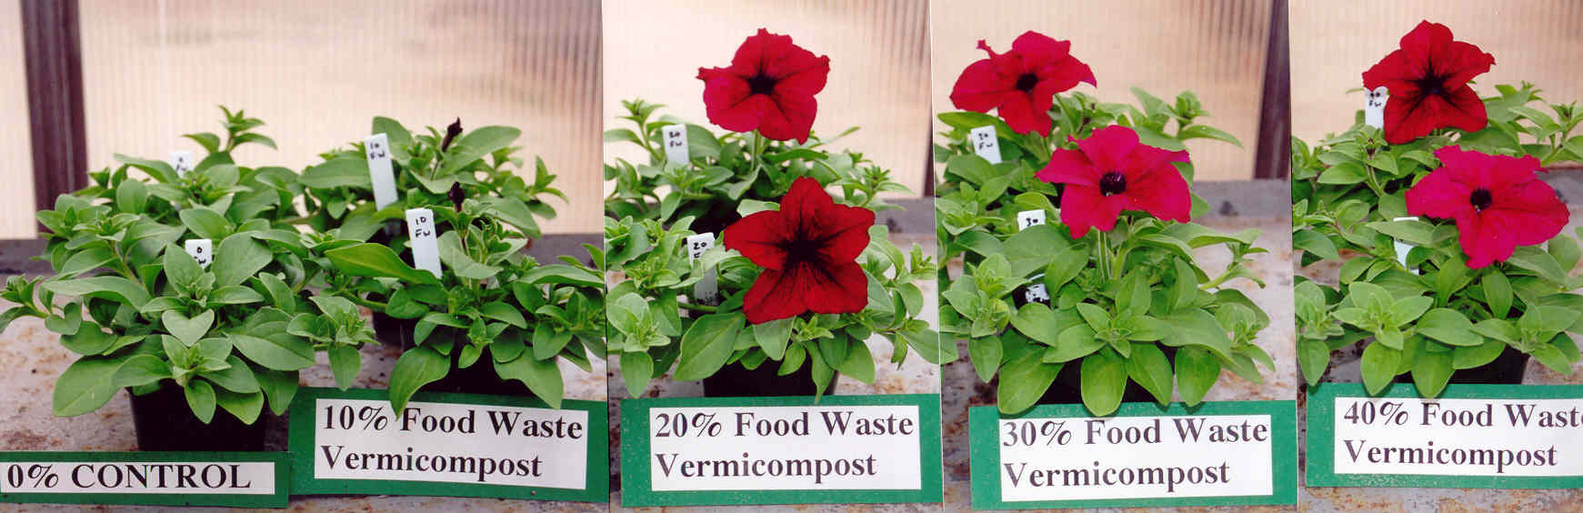

Figure 1. Number of flowers on petunias grown in food waste vermicompost and MetroMixM360 (with all needed nutrients supplied).

Solid vermicomposts have been shown to increase the germination rates of growth, flowering, and yields of a wide range of crops such as petunias (Figure 1. Arancon et al, in press), marigolds, chrysanthemums, tomatoes, peppers (Figure 2. Arancon et al 2004), grapes, and strawberries, for both greenhouse and field crops. In the greenhouse, rates of substitution of from 20-40% vermicomposts, into commercial plant growing media, have been shown to be the most effective in increasing crop yields. In the field, application rates of 1.25-5.0 tons of vermicompost per ha have had excellent effects on growth and yields of many crops.

\Figure 2. Mean yields and mean fruit weights of peppers produced in standard commercial medium (Metro-Mix 360) substituted with different concentrations of food waste vermicompost. Columns followed by the same letters do not differ significantly (P<0.05, with all needed nutrients supplied).

Vermicomposts have also been shown to suppress attacks by soil and foliar transmitted plant diseases, such as Pythium, Rhizoctonia, Plectosporium and Verticillium, significantly in both the field and greenhouse. Vermicomposts can also suppress arthropod pests such as caterpillars: including cabbage white caterpillars, tomato hornworms, and cucumber beetles, as well as sucking arthropods: such as scale insects, mealy bugs, aphids (Figure 3) and spider mites (Arancon et al, 2005b, 2006). The suppression of aphids is particularly important, since they are major transmitters of plant viruses. The vermicompost applications to soils appear to make the plants that are grown in them less attractive to the pests but also by suppressing their reproduction.

Figure 3 - Development of aphid populations (Means ± SE) on cabbages, grown in a soilless medium, Metro-Mix 360 (MM360), substituted with food waste vermicomposts. Measurements made over on seven dates over 17 days after infestations. Means designated by * and ** are significantly different at P ≤ 0.05 and P ≤ 0.01, respectively.

Finally, it has been shown at The Ohio State University that vermicomposts can suppress attacks by plant parasitic nematodes such as tomato cyst eelworm and root knot nematodes such as Meloidogyne, on tomatoes and other vegetable crops dramatically. (Arancon et al, 2003).

Production of aqueous extracts of vermicompost or ‘teas’

In recent years, crop growers have been producing aqueous extracts of composts, and vermicomposts, commonly termed ‘teas’, and found particularly that vermicompost ‘teas’ can increase crop germination and growth in ways similar to the solid vermicompost materials and are much easier to apply to crops and soils. Work at The Ohio State University has shown that the best method of producing ‘teas’ is with commercial extraction equipment, using organic wastes that are aerated and soaked for about 24 hours. Vermicompost ratios of waste to water, of 1:5, 1:10, and 1:20 were most effective and economic in terms of treatment costs. ‘Teas’ produced at these dilutions can affect plant growth significantly when applied as soil drenches. It is recommended that the ‘teas’ are used soon after they are produced.

Uses of vermicompost ‘teas’

These aqueous vermicompost extracts or ‘teas’ are much easier to transport and apply, than solid vermicomposts, and can duplicate most of the benefits of vermicomposts when applied to the same crops. Additionally, they can be applied to crops as foliar sprays.

Figure 4. Increases in tomato mean shoot dry weights in response to aerated food waste vermicompost ‘tea’ applications compared to a water control to plants growing in MM360 (with all needed nutrients supplied)

Work at The Ohio State University has shown that vermicompost ‘teas’ increased the germination, growth, flowering, and yields of tomatoes (Figure 4), cucumbers, and other crops in similar ways to solid vermicomposts. The aerated, vermicompost ‘teas’ suppressed the plant diseases Fusarium (Figure 5) Verticillium, Plectosporium, and Rhizoctonia to the same extent as the solid vermicomposts. (Edwards et al, 2006)

Figure 5. Suppression of the plant diseases Fusarium by drenches of food waste vermicompost and vermicompost ‘teas’ compared to a water control (with all needed nutrients supplied).

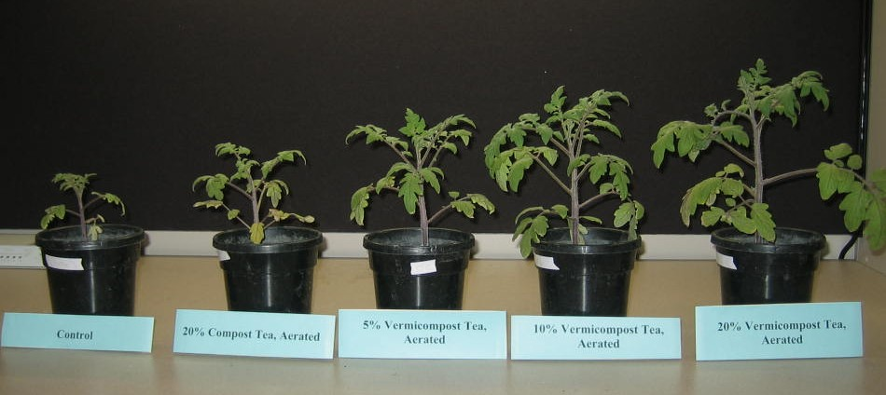

Control 20% Compost 5% vermicompost 10% vermicompost 20% vermicompost
(water) ‘tea’ tea’ ‘tea’ ‘tea’

Figure 6a. A comparison of tomato plants infested with Meloidogyne hapla and treated with vermicompost or thermophilic compost ‘teas’. Plants were grown in MM360 (with all needed nutrients supplied).
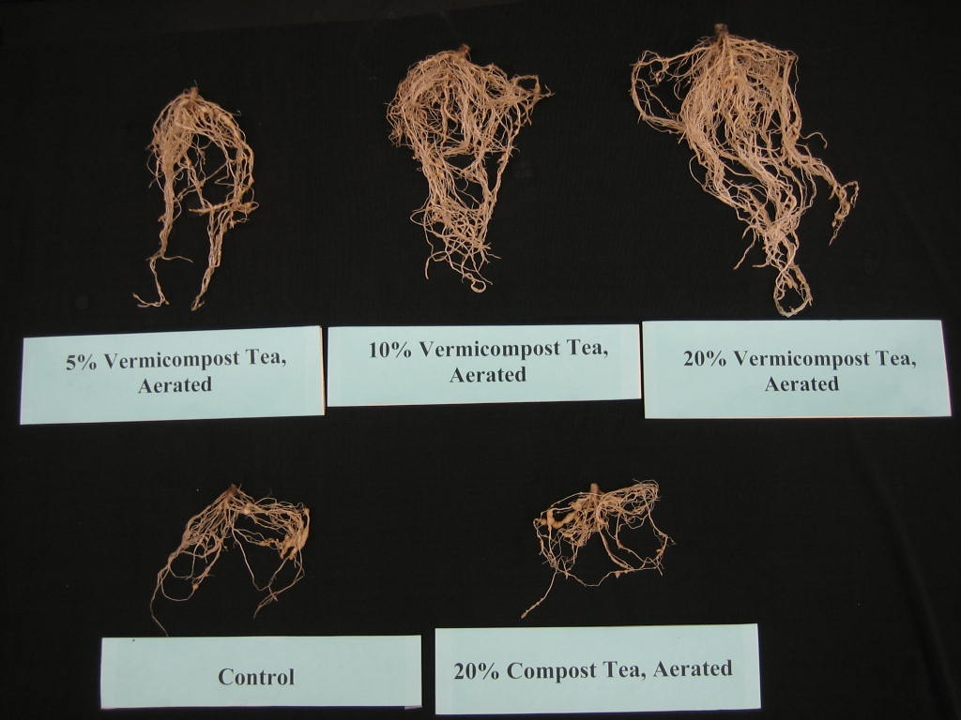

Figure 6b. The roots of tomato plants infested with Meloidogyne hapla and treated with 5%, 10%, 20% aerated vermicompost ‘teas’ or 20% thermophilic compost ‘tea’ compared with those treated with only water control (with all needed nutrients supplied).

Vermicompost ‘teas’ also suppressed populations of spider mites (Tetranychus urticae) and aphids (Myzus persicae) significantly.
Additionally, they had dramatic effects on the suppression of attacks by plant parasitic nematodes such as Meloidogyne on tomatoes both in terms of reducing the numbers of root cysts significantly and increasing root and shoot growth (Figure 6a and 6b).
Conclusions

Clearly, vermicomposts and vermicompost ‘teas’ that can be produced from organic wastes, such as food and wastes, have enormous economic potential for increasing crop yields and suppressing attacks by important pests and diseases. The vermicomposting process takes materials with considerable negative and economic problems, associated with their disposals in land fills and other ways, and create from them value-added products which can increase food production dramatically.

References

Arancon, N.Q., Yardin, E., Edwards, C.A., Lee, S. 2003. The trophic diversity of nematode communities in soils treated with vermicomposts. Pedobiologia. 47, 731-735.

Arancon, N.Q., Edwards, C.A., Babenko, A., Cannon, J., Galvis, P., Metzger, J.D. 2007. Influences of vermicomposts produced by earthworms and microorganisms from cattle manure, food waste, and paper waste on the growth and flowering of petunias in the greenhouse. Applied Soil Ecology (in press).

Arancon, N.Q., Edwards, C.A., Bierman, P., Metzger, J.D., Lucht, C. 2005b. Effects of vermicomposts produced from cattle manure, food waste and paper waste on the growth and yields of peppers in the field. Pedobiologia 49, 297-306.

Arancon, N.Q., Edwards, C.A., Lee, S., Byrne, R. 2005a. Effects of Humic Acids from Vermicomposts on Plant Growth. European Journal of Soil Biology. 42, 65-69.

Arancon, N.Q., Galvis, P., Edwards, C.A., 2005b. Suppression of insect pest populations and plant damage by vermicomposts. Bioresource Technology. 96, 1137-1142.

Arancon, N.Q., Edwards, C.A., Yardim, E.N., Oliver, T., Byrne, R.J., Keeney, G., 2006. Suppression of two-spotted spider mite (Tetranychus urticae) mealy bugs (Pseudococcus sp) and aphid (Myzus persicae) populations and damage by vermicomposts. Crop Protection. 26, 29-39.
Arancon, N.Q., Edwards, C.A., Atiyeh, R.M., Metzger J.D., 2004. Effects of vermicomposts produced from food waste on greenhouse peppers. Bioresource Technology. 93, 139-144.

Edwards, C.A., Arancon, N.Q., Greytak, S., 2006 Effects of Vermciompost Teas on Plant Growth and Diseases. Biocycle. May 2006, 28-31.
Edwards, C.A., Bohlen, P., 1996. Biology and Ecology of Earthworms (3rd Edition) Chapman and Hall, London 426 pp.

Edwards, .C.A, Arancon, N.Q. 2004. The Use of Earthworms in the Breakdown of Organic Wastes to Produce Vermicomposts and Animal Feed Protein. In Earthworm Ecology (2nd edition) Editor C.A. Edwards. CRC Press, Boca Raton, FL, London, New York, Washington. 345-438.

